BudgetBuddyProject

**Guide Content:**

* Project Description
* Project Features
* Technology Used
* Directions for Login
* Directions for Signup
* Directions for Homepage
* Directions for Income Tracker
* Directions for Expense Tracker
* Directions for Reminders
* Directions for Overview

**Description**

The main point of this project is to provide an “organizer” for financial transactions. A user can add expense and income amounts with their respective category or source, as well as a reminder for a certain upcoming financial event. Finally, there is an overview that shows the overall expenses and incomes, as well as the user’s total balance.

**Features**

1. Sign up: each user can create his/her own personal account with their very own credentials (username, password, email)
2. Login: all data a user inputs are saved into his/her account, where they can login at any time using their credentials (username, password)
3. Homepage: the homepage is the main page that has links to navigate to every other one (Overview, Expense Tracker, Income Tracker, Reminders)
4. Adding an expense: once a user is in the Expense Tracker page, he/she will have the option to add an expense to his/her total balance by entering its amount (must be positive of course) and select an option from a choice box that showcases all the possible categories an expense falls into.
5. Table of expenses: once the user adds an expense, it will automatically be added to a table which shows the category that the expense falls into and its amount, as there will also be a total expense amount that updates each time for the user to see.
6. Adding an income: once a user is in the Income Tracker page, he/she will have the option to add an income to his/her total balance by entering its amount (must be positive of course) and select an option from a choice box that showcases all the possible sources an income falls into.
7. Table of incomes: once the user adds an income, it will automatically be added to a table which shows the source that the income falls into and its amount, as there will also be a total income amount that updates each time for the user to see.
8. Adding a reminder: once the user enters the Reminders page, he/she will have the option to add a reminder for future financial events (electricity bill, water bill, rent, payday…) by entering its description, selecting a date from the date picker, and choosing its recurrence pattern (once, daily, weekly, monthly, yearly).
9. Table of reminders: once the user adds a reminder, it will automatically be added to a table which shows the reminder’s description, as well as the date that was selected by the user.
10. Overview: once a user enters the Overview page, he will see two tables with all of his/her expenses and incomes listed, as well as two pie charts showing how the income and expense amounts are divided. Finally, he/she will be shown his/her total balance.

**Technology Used**

1. JavaFX (on IntelliJ)

* Provides a wide range of UI components to create visually appealing and interactive interfaces.
* Can run on many different operating systems (Windows, macOS, Linux…)
* Built-in scene builder for easy design of UI layouts.

1. FXML

* Provides a clear and declarative way of defining UI layouts.
* Promotes a clean and maintainable code by effectively separating the presentation layer from the application logic.

1. JSON (JavaScript Object Notation)

* An easy and effective way to transmit data between the backend and frontend of an application.
* Widely supported by many programming languages and frameworks.

1. HTTP Requests (POST / GET)

* Allow the frontend part of the application to smoothly communicate with the backend server, in this project it enabled actions like adding expenses and incomes, managing reminders, and retrieving data.
* Performs tasks asynchronously.

1. FXMLLoader

* Enables dynamic loading of FXML files at runtime.

1. Spring Framework

* Powerful and flexible framework for building RESTful API endpoints and mappings.

1. OkHttp

* Efficient HTTP client, used for making HTTP requests and handling responses in the frontend.
* Allows for connection pooling.

1. Hibernate

* Simplifies database interactions by mapping Java objects to database tables (models).

1. MySQL

* To properly store and retrieve all the data requested.
* Provides a good platform for building an efficient RDB with proper relations.

1. Spring Boot

* Provides efficient embedded servers and auto-configuration.
* Simplifies setup of Spring-based applications.

1. HashMap and ArrayList

* Properly structures data retrieved from the backend.

**Project Guide**

**Login Page:**

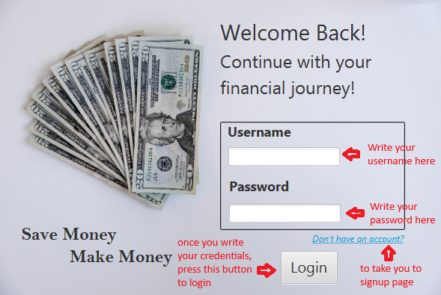

If you already have an account, you can simply enter your username (not case sensitive) and your password (case sensitive) in their respective text fields. Then you just press on the “Login” button. If you get an error “Invalid username or password”, it means you either don’t have an account, or you put your credentials incorrectly. Otherwise, you will be directed to the Homepage.

If you don’t have an account, just press on the small blue link “Don’t have an account?” and it will direct you to the signup page.

**Signup Page:**

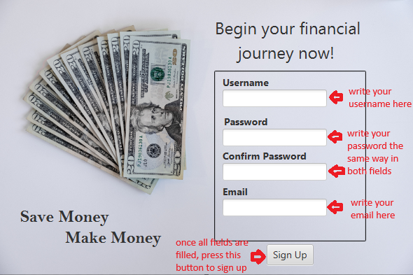

Here, you are creating an account to be able to use the Budget Buddy application. Enter your username, password, and email (email must be in the correct format: [------@----.com](mailto:------@----.com)) in the respective fields. In the confirm password field, write your password exactly the same way (it is to avoid any typos in the password for later login). Press the signup button and you will be taken back to the login page where you should put these credentials again. Make sure to fill in all fields.

**Homepage:**

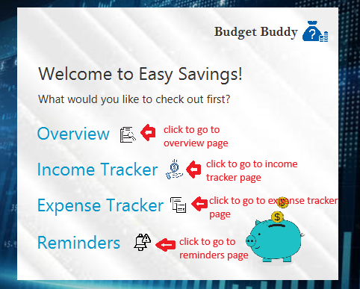

After you have successfully logged in, you will be directed to this Homepage. From here you can go to any page you’d like. Just press on any link to take you to the respective page.

**Income Tracker Page:**

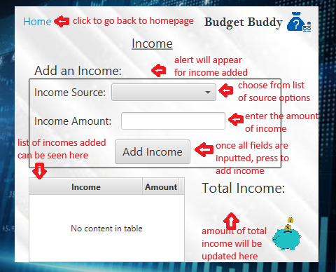

If you pressed on the Income Tracker link, you will be directed here. You can choose a source for the income you want to add from a list of options, then enter the amount of the income you want to add (in US dollars). If it is negative, the income won’t be added and you will get an alert (instead of the income added alert) that the amount can’t be negative.

Finally, press on the “Add Income” button (make sure both fields are filled) and you will see the table automatically adding a new income, as well as the total income amount updating according to the amount you added.

You can press on the “Home” link in the upper left corner to go back to the Homepage.

**Expense Tracker Page:**

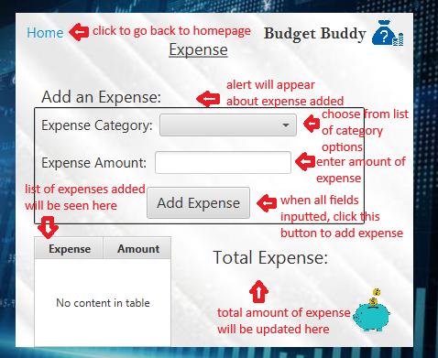

If you pressed on the Expense Tracker link, you will be directed here. You can choose a category for the expense you want to add from a list of options, then enter the amount of the expense you want to add (in US dollars). If it is negative, the expense won’t be added and you will get an alert (instead of the expense added alert) that the amount can’t be negative.

Finally, press on the “Add Expense” button (make sure both fields are filled) and you will see the table automatically adding a new expense, as well as the total expense amount updating according to the amount you added.

You can press on the “Home” link in the upper left corner to go back to the Homepage.

**Reminders Page:**

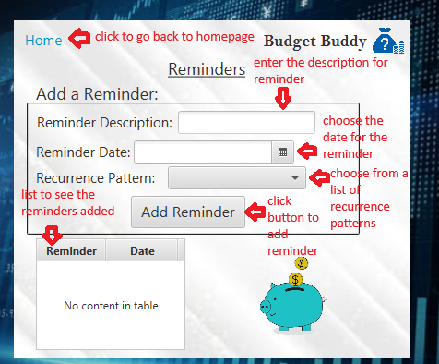

If you pressed on the Reminders link, you will be navigated here. You can first enter a description for the reminder (water bill, rent, payday…), then press on the calendar icon to select a date for that reminder. Finally, you have options for recurrence patterns for the reminder (Once, Daily, Weekly, Monthly, Yearly) to choose from.

When all fields are entered, you press on the “Add Reminder” button to add it. It will then automatically be added to the table that lists all the reminders you have.

You can then press on the “Home” link in the upper left corner to go back to homepage.

**Overview Page:**

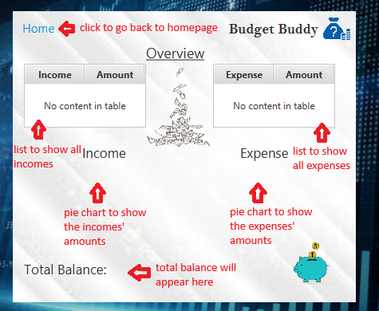

If you pressed on the Overview link, you will be navigated to this page. Here, you will have an overall summary of your expenses, incomes and total balance. You can see two tables that list the incomes and expenses you added, as well as two pie charts that show the division of the amounts of incomes and expenses. Finally, your total balance will be portrayed as the total amount of income – total amount of expense.

You can press on the “Home” link in the upper left corner to go back to homepage.